Specifying an operating model for Canary Rockfish, (*Sebastes pinniger*) in British Columbia waters

Technical report for Fisheries and Oceans Canada



Tom Carruthers *[1]*

**V3.2.3**

Robyn Forrest

Greg Workman

December 2016

*Based on* Stock assessment report (‘Assessment’)

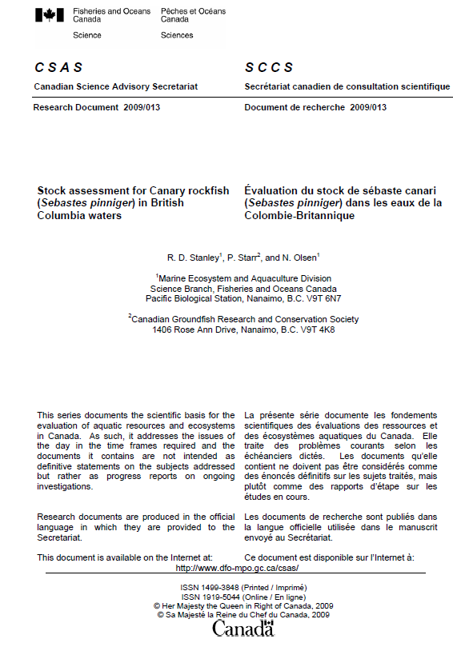

Table of Contents

1 Feasibility 4

The Feasibility .csv file 4

2 Specifying stock dynamics 5

The stock .csv file 5

Mortality and age 6

Recruitment 7

Growth 8

Stock depletion 9

Length-weight conversion parameters and maturity 9

Spatial distribution and movement 10

Non-stationarity in stock productivity 10

Maturity 11

Source of information 11

3 Specifying fleet parameters 12

The fleet .csv file 12

Name, historical years of fishing, spatial targeting 12

Inter-annual variability in fishing effort, annual increase in catchability, inter-annual variability in catchability 13

Trend in historical fishing effort 14

Fishery length selectivity 15

4 Specifying observation error model parameters 16

The observation 16

5 References 17

# Feasibility

The Feasibility .csv file (Fease_CR.csv)

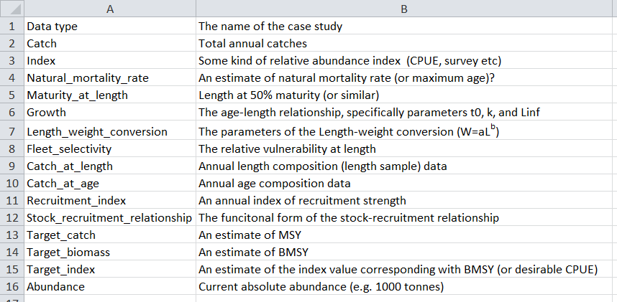

In most data-limited settings one or more types of data may be missing or unprocessed. It may be desirable to begin the Management Strategy Evaluation (MSE) by constraining the computationally intensive analyses to only those management procedures (MP) that can be applied in practice.

Having said this there are good reasons to include a wider range of MPs than the available data allow. For example MSE testing of a wider range of MPs may reveal those that perform much better thereby justifying the collection of other data.

Since stock assessments have been carried out for Canary Rockfish all data types are available and no MPs can be ruled out *apriori*.

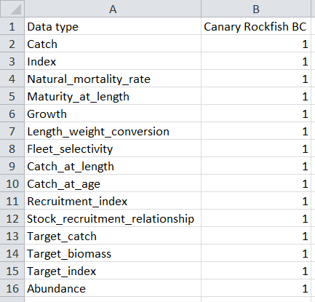

# Specifying stock dynamics

The stock .csv file (Stock_CR.csv)

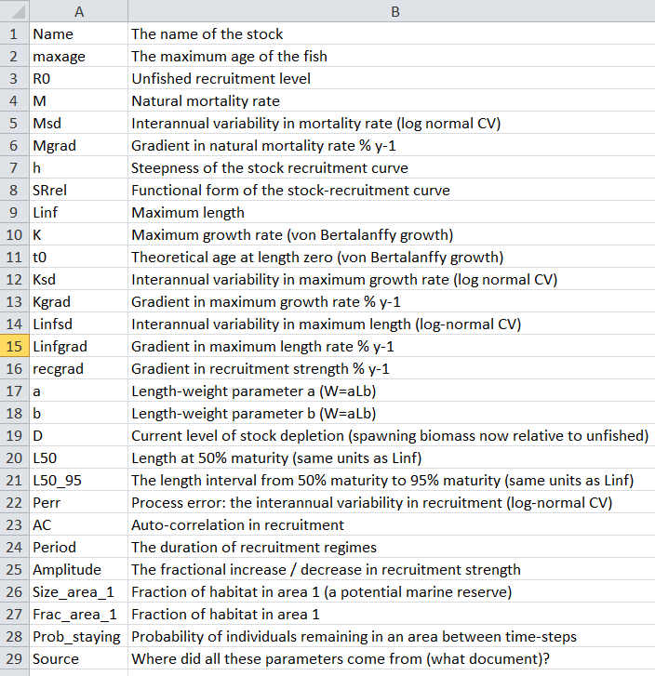

The critical parameters

Typically the performance of management procedures is most strongly determined by longevity and stock productivity (M), resilience to fishing (h), stock level relative to unfished (D), non-stationarity in productivity (AC, but also Kgrad), length at maturity (L50, L50_95) and the variability in recruitment (Perr).

However there are few general rules. For example:

* if an MP is selected based on its ability to achieve certain biomass levels and the fish is short-lived (high M) and has high recruitment variability (Perr) then the starting level of stock depletion (D) may have little bearing on performance over a 50 year projection.
* the influence of length at maturity is entirely determined by the length-selectivity of fishing and may be unimportant if it is always well below the length at which individuals become vulnerable to fishing.
* none of the parameters above will be important if performance is related to avoiding low stock sizes and 60% of a viscous stock is found in a reserve (Frac_area_1 = 0.6, Prob_staying > 0.98)

Mortality and age: (#1-6) Name, maxage, R0, M, Msd and Mgrad

Name: the same fishery name as the assessment ‘Canary Rockfish BC’

M: the assessment assumes a point value of *M* of 0.06 y-1 (page 12) for both male fish and females aged 0-13. This was bracketed by +/- 30% leading to a mean *M* in the range of 0.04 – 0.09 to represent uncertainty commensurate with the brief assessment review of *M* values that have been applied previously ranging from 0.02 in young males to 0.12 for older female fish.

Msd: given that M is very poorly quantified in most fishery settings, the annual variability in M is poorly known but likely to vary due to variability in predation pressure, food availability, disease and the density of the stock and related stocks that compete for prey or cannibalize recruits. To address the possibility of M changing among years in these simulations I set an arbitrary level of inter-annual variability with a lognormal CV of between 5% and 20% (i.e. 0.05 – 0.2), corresponding with 95% probability interval of +/-10% to +/- 40%. Note that due to the longevity of Canary Rockfish quite substantial inter-annual variability in M would be necessary to generate data inconsistent with the assumption of time-invariant M (noting the possible exception of a trend in M, below).

Mgrad: persistent underlying trends in natural mortality have been hypothesized in response to increasing numbers of predators. In the reference operating model I assume that there is essentially no trend in M allowing a rate of -0.1 and 0.1 % per year.

maxage is the maximum age for which calculations are carried out, the only reason not to make this very large for all stocks (e.g. 500) is that the more ages, the greater the number of calculations and the slower the MSE will run. Here we assume a maximum age of 116 which roughly corresponds with the age at which survival is 1% given the lowest bound on natural mortality rate of 0.04, ie. –ln(0.01)/0.04 = 115.13.

R0: the level of unfished recruitment. Unless management options are specified in absolute numbers (e.g. tonnes) the MSE is scale-less (has no units) and this value is inconsequential. Here it is set to 1000 arbitrarily.

*Note on OM misspecification:*

The assessment has age-invariant natural mortality rate for males and age-invariant natural mortality rate for females (0.09 for age 14+). Age-specific *M* is an update for DLMtool v3.2.3

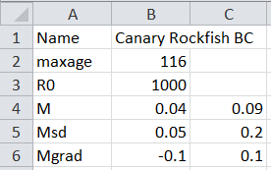

Recruitment (#7, 8, 16, 22 and 23): h, SRrel, recgrad, Perr, AC

h: the steepness of the stock-recruitment curve (unfished recruitment at 20% unfished spawning biomass). The assessment specifies two possible values for steepness (Table J.6., page 156) that are used here to specify a range of values: 0.55 – 0.70.

SRrel: a value of 1 represents the Beverton-Holt stock recruitment curve to match that of the assessment.

Perr: the magnitude of annual recruitment deviations. Figures J.5, J.9, J.13 (pages 172, 175, 178 of the assessment, respectively) show inter-annual variability expressed as a log-normal CV in the range of 0.25 –0.32 (see Figure 1 below).

AC: the lag 1 autocorrelation in recruitment. Figures J.5, J.9, J.13 (pages 172, 175, 178 of the assessment, respectively) show recruitment autocorrelation of between 0.75-0.81 (see Figure 1 below)

recgrad: [for DLMtool version 3.2.3] the historical recruitment deviations show essentially no temporal trend (red horizontal line is the mean trend in Figure 1) and I arbitrarily set this to a range close to zero of between -0.1 and 0.1 % per year change in recruitment strength.

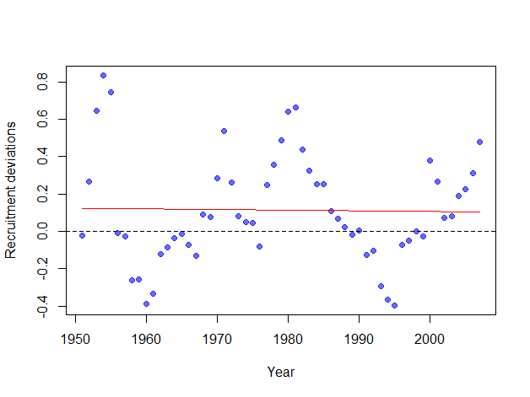

Figure 1. The recruitment deviations ripped from Figure J.13 of the report. Standard deviation of recruitment residuals is 0.28, lag-1 auto correlation is 0.78. The red line shows the mean trend which has a slope of -0.003 yr-1.

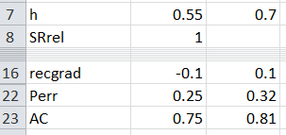

Growth (#9-15): Linf, K, t0, Ksd, Kgrad, Linfsd, Linfgrad

The assessment report does not mention anything about growth but does reference Watters and Oda (1997).

Linf: maximum length. The value for females is taken from Table 3, page 9 of the assessment: 56.9cm. Arbitrarily, a small degree of uncertainty is used to bracket this value, +/- 2.5%: 55.5 – 58.3.

K: maximum growth rate. The value for females taken from Table 3, page 9 of the assessment: 0.163. Arbitrarily, a moderate degree of uncertainty is used to bracket this value, +/- 10%: 0.147 – 0.179.

t0: theoretical age at length zero. The value for females is taken exactly and no uncertainty is simulated: -0.561.

Ksd: inter-annual variability in growth rate expressed as a log normal standard deviation. Studies of temporal variability in growth of rockfish are not common but older studies of rockfish growth have found moderate inter-annual variability in K values among years with a CV of around 25% (e.g. widow rockfish, Pearson and Hightower 1991): here we set it in the range of 0.2 – 0.3.

Kgrad: the mean temporal gradient in growth rate K. This is set to zero in the absence of evidence for a possible temporal trend: 0.

Linfsd: the inter-annual variability in maximum length expressed as a log normal standard deviation. Taken from the same study above, this is relatively constant and given a CV in the range of 0.05 - 0.1.

Linfgrad: the gradient in underlying maximum length at age. As Kgrad this was assumed to have no trend: 0.

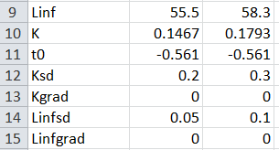

*Robustness testing:*

A temporal gradient in K is included in the robustness set of between -1% to 1% per year: -1 to 1

Stock depletion (#19): D

D: initial stock depletion (at the end of the historical period), the spawning stock biomass today relative to unfished conditions. Since we have a stock assessment with multiple model runs it is relatively straightforward to bracket uncertainty. Table J.10 of page 159 of the assessment provides posterior mean estimates for all models which range from 0.12-0.35.

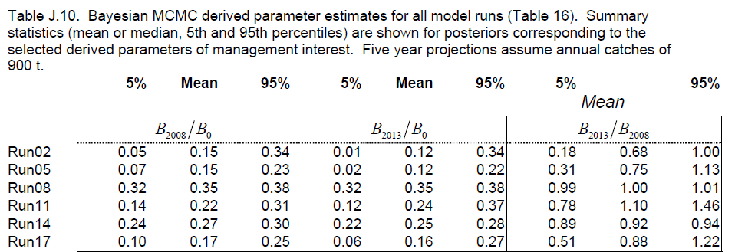



Length-weight conversion parameters and maturity (#17, 18): a, b

a and b: the length-weight conversion parameter a W=aLb. Here weight W is in grams, length L is in cm. The assessment document provides these values in Table 3 page 9 and those of females are used here and assumed to be known without error: 1.37E-5 and 3.06

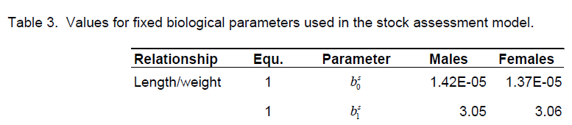

Note that similarly to unfished recruitment R0, these parameter values are scalers and generally don’t strongly affect MSE outputs unless MPs are tested that are in specific units.



Spatial distribution and movement (#26-28): Size_area_1, Frac_area_1, Prob_staying

It is unlikely that a substantial fraction of Canary rockfish (a deep water rockfish species) inhabits the near shore protected areas. There is some possibility for refuges (‘technical closed areas’) where canary rockfish are present but it is unprofitable or not feasible to fish. In this analysis I specify a small prospective (candidate - for testing of MPs that close areas) closed area that has moderate stock mixing.

Frac_area_1: fraction of unfished habitat in area 1 of 2. Frac_area_1 is the default area for testing marine reserves or habitat that is outside of the range of fishing. To simulate a mixed stock we simulate a stock in which 10% of individuals are in area 1 and 90% are in area 2, 0.1.

Prob_staying: To simulate uncertain mixing among areas I assume that between 85% and 95% of individuals remain in the same area among years, 0.85 - 0.95.

Size_area_1: to account for spatial targeting the toolkit has a slot for the size of each area (to inform density of fish), however this feature is under development so it is set to be the same as the habitable area (Frac_area_1), 0.1.

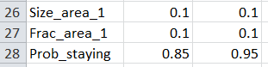

*Robustness testing:*

It might be worth experimenting with a range of values for Prob_staying and Frac_area_1, to evaluate when stock viscosity influences MP performance given varying fractions of the stock that are not available to fishing, e.g. Frac_area_1: 0 - 0.1 and Prob_staying: 0.8-0.99.

Non-stationarity in stock productivity (#24-25): Period, Amplitude

Period: the duration of recruitment regimes. In this case we assume no regime shifts and leave this blank

Amplitude: the potential fractional magnitude of a recruitment increase/decrease. Again we don’t simulate regime shifts and leave this blank.



Maturity (#20, 21): L50 and L50_95

The maturity at age schedule is illustrated in Figure 29, page 37 of the assessment. However in DLMtool, maturity is specified by length. It was therefore necessary to covert ages to lengths using the simulated growth curves.

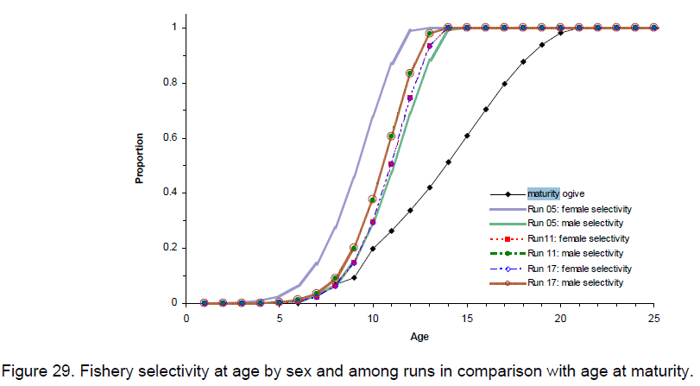

L50: the length at which 50% of individuals are mature. The assessment specifies 50% maturity at age 14. Using the lower bound on K and Linf, the growth curve predicts a length of 48.38 cm= 55.5(1-e-0.1467 x 14). Using the upper bound on K and Linf, the growth curve predicts a length of 53.56 cm = 58.3(1-e-0.1793 x 14). This is quite a naïve basis for guessing length at maturity since it does not account for aging error (compresses uncertainty) but then exaggerates uncertainty by using lower and upper bound pairs of the K and Linf growth parameters that are typically negatively correlated.

L50_95: the length interval between the length at 50% maturity and 95% maturity. Using the same approach above but assuming that 95% of individuals are mature at age 19.5, the length at 95 maturity is bounded by 52.32 cm and 56.53 cm which are 3.94 cm and 2.97 cm longer than the respective bounds on L50 and these are represented in the simulations as a gap of between 3 and 4 years to 100% maturity (once again exaggerating the uncertainty in the maturity ogive to some extent).



Source of information (#29): Source

Source: the primary source of information supporting the specification of the stock object. Here we credit the hard work of Stanley, Starr and Olsen: Stock assessment for Canary rockfish (*Sebastes pinniger*) in British Columbia waters. Stanley R. Starr P. Olsen N.

# Specifying fleet parameters

The fleet .csv file (Fleet_CR.csv)

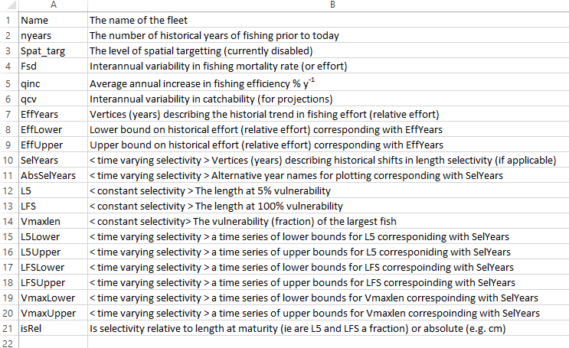

The critical parameters

The trajectory in fishing mortality rate described by EffLower and EffUpper is the key determinant of whether the stock is currently subject to overfishing or underfishing, depending of course, on the level of stock depletion D specified in the Stock object (Stock@D).

Similarly, the length selectivity of fishing interacts with the length a maturity to determine whether the stock is subject to growth (catching fish that are two small) or recruitment overfishing (catching fish that are fecund).

Name, historical years of fishing, spatial targeting (#1-3): Name, nyears, Spat_targ

Name: similarly to the stock name we’re going to relate this to the assessment, ‘Canary Rockfish BC’

nyears: The data from the assessment run from 1940-2007, a total of 68 years.

Spat_targ: The spatial targeting of the fishery. This feature is currently being developed for DLMtool, we’re going to stick to the default level of 1 (targeting in proportion to density) in preparation for its implementation.

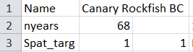

Inter-annual variability in fishing effort, annual increase in catchability, inter-annual variability in catchability (#4-6): Fsd, qinc, qcv

Fsd: interannual variability in fishing effort (expressed as a CV). This is really variability in addition to the underlying trend described by EffLower and EffUpper. It is used only to generate historical fishing patterns. In data-limited cases a very simple (general, mean) historical trajectory in effort may be established and it may be desirable to add additional interannual variability to reflect changes in fishing intensity among years. In this case we’re going to be using stock assessment outputs directly that have detailed annual variability information and have no need to superimpose greater variability. It is set to 0.

qinc: trend in fishing efficiency (projections). In the future, is a unit of effort going to lead to higher fishing mortality (positive qinc) or lower fishing mortality (negative qinc). The fishery report and assessment provide no compelling reason to expect fishing to become more or less efficient and we set the % annual increase to be very close to zero, -0.1 to 0.1.

qcv: interannual variability in fishing efficiency. Given an assessment, variability in fishing efficiency among seasons can be quantified by comparing observed unstandardized catch rates with an index of abundance (or assessed biomass). In the assessment (Figure H.2. page 117) catch rate data show a very little variability among years. This implies at most very low degree of variability in catchability which is represented here by a log-normal standard deviation between 0.01 and 0.03.

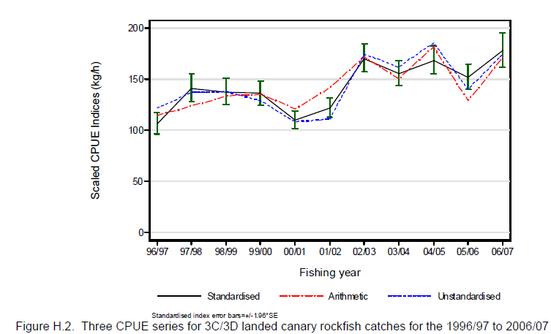

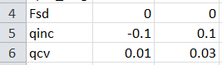

Trend in historical fishing effort (exploitation rate) (#7-9): EffYears, EffLower, EffUpper

Specifying historical pattern of exploitation rate (relative fishing mortality rate (sometimes assumed to be proportional to fishing effort) is easy in this case as we have the stock assessment prediction of exploitation rate (Figure J.5, page 172). I used WebPlotDigitizer (<http://arohatgi.info/WebPlotDigitizer/app/>) to rip these data. Table J.9 on page 159 shows considerable uncertainty in exploitation rates with a mean range of +/- 40% for harvest rate in 2007, bounds that used here to bracket the trend extracted from Table J.5.

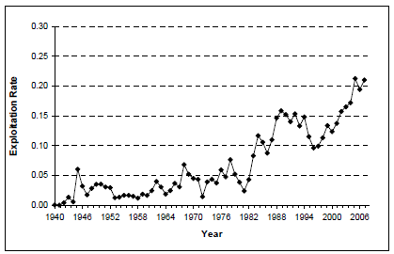 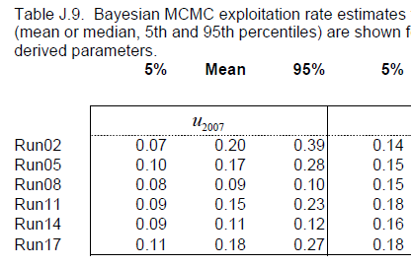

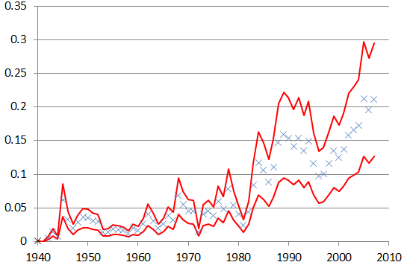

Figure 2. Relative fishing effort derived from stock assessment estimates of exploitation rate.

EffYears: this is the vertex (year) for a major change in effort (fishing mortality rate). In this case this is just 1940-2007 which is years 1-68, hence we make this 1, 2, 3, … 22.

EffLower: we could use the lower bound for the assessment predicted fishing mortality rate, these are treated as relative effort and are scale-less (there are rescaled for presentation purposes but identical in trend to Figure 2 above): 0.01, 0.01, 0.04, 0.012, 0.05…

EffUpper: as effort lower: 0.02, 0.02, 0.10, 0.28, 0.13…





Fishery length selectivity (#10-21): SelYears, AbsSelYears, L5, LFS, Vmaxlen, L5Lower, L5Upper, LFSLower, LFSUpper, VmaxLower, VmaxUpper, isRel.

The assessment provided reasonably consistent selectivity curves for both time periods (Figure 11, page 13). Here we assume time invariant selectivity and therefore only make use of the slots, L5, LFS, Vmaxlen and isRel.

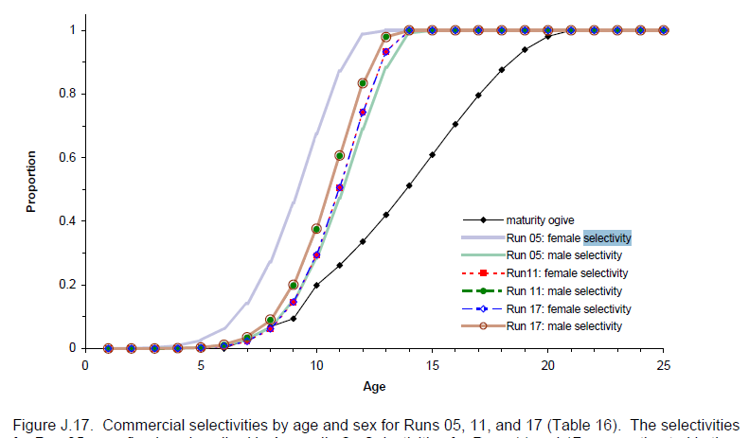

Vmaxlen: following figure J.17 and the behavior is assumed that the vulnerability of the largest, oldest fish is 100% (flat-topped selectivity) and we specify a value of 1.

L5: similarly to maturity in the stock object, one naïve approach is to use the selectivity at age of Figure J.17 and the growth curve to derive the length at 5% selectivity. Given a lower age of 6 (run 05 female), and using the lower bound on K and Linf, the growth curve predicts a length of 32.48cm= 55.5(1-e-0.1467 x 6). Using the upper age of 7 (run 17 female) and the lower bound on K and Linf, the growth curve predicts a length of 41.68cm = 58.3(1-e-0.1793 x 7).

LFS: the assessment selectivity curves estimate 100% selectivity at age 5. Using the same approach for placing bounds on L5 we get values of 47.25cm= 55.5(1-e-0.1467 x 13) and 53.56cm = 58.3(1-e-0.1793 x 14).

isRel: in this case this is set to 0 because we are not specifying L5 and LFS as a fraction of length at maturity but rather in absolute units (cm) the same as those of the growth and maturity parameters.

SelYears, AbsSelYears, L5Lower, L5Upper, LFSLower, LFSUpper, VmaxLower, VmaxUpper: time varying selectivity parameters. Since constant selectivity is assumed here these parameter values are set to NA.

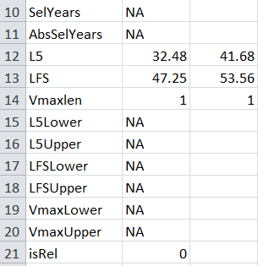

# Specifying observation error model parameters

The observation .csv file

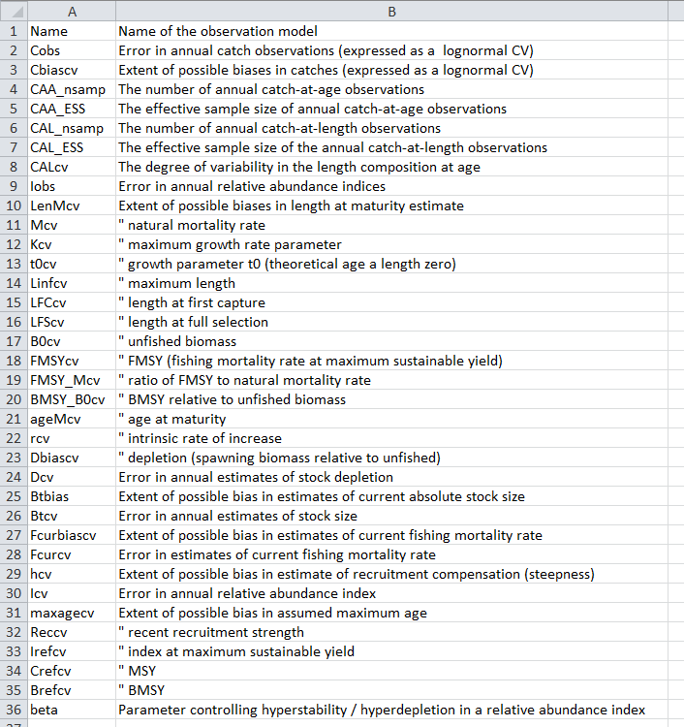

The critical parameters

In general, at least one of these data sources are used by each of the MPs in DLMtool which means that increasing the bias or imprecision in a particular data source can strongly determine the performance of one or more MPs.

Using default observation models

In this MSE application, multiple observation error models are considered that are included in the DLMtool package and have default parameter values. If these observation models provide substantially different results it may be necessary to tailor the parameters to specific Canary Rockfish case study. Three observation error models are to be analysed: Precise_Unbiased (good quality data), Generic_obs (fair data quality), Imprecise_Biased (moderate quality data).

# References

Pearson, D.E., Hightower, J.E. 1990. Spatial and temporal variability in growth of widow rockfish (Sebastes entomelas). NOAA technical memorandum. NOAA-TM-NMFS-SWFSC-167. Available at: <https://swfsc.noaa.gov/publications/TM/SWFSC/NOAA-TM-NMFS-SWFSC-167.PDF> [accessed Nov 2016].

1. [bluemattersci@gmail.com](mailto:bluemattersci@gmail.com), 2150 Bridgman Ave, North Vancouver, BC, V7P 2T9. +1 604 805-6627